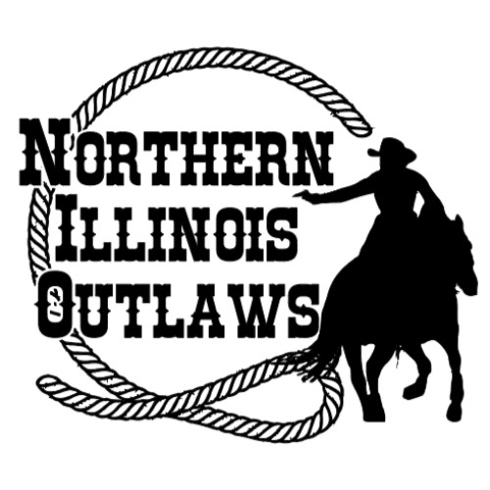
New Shooters Clinic
Sunday April 14, 2024
Check in at 9:00 a.m., coffee and kringle provided
Clinic starts at 10:00 a.m.
C4 Ranch – 19102 McGuire Rd. Harvard, IL 60033
Please provide one completed application for each participant
Limited to 10 participants
Pre-registration deadline April 6, 2023

You do not need your own guns, holsters or ammo, the NIO will provide these items. The only thing you need to bring is you, your horse, copy of coggins (email is ok as well),Health Certificate (out of state only), your western tack, and must wear a long sleeved shirt. Horse must neck rein.

Name: __________________________________________________________________
Address: ________________________________________________________________
City: _________________________________State: ___________ Zip: __________
E-Mail: __________________________________________________________
Phone: area code: (____)________________________
Complete New Shooters Clinic – per person $150.00 ____
Classroom session only - per person $100.00 _____
Stall for the day (Not Required, horse may be left in trailer) $25.00 ____
Lunch to be Determined
Make checks payable to Northern Illinois Outlaws
Mail to: Ashley(Fearless) Owens, NIO Treasurer, 20316 98th St. Bristol, WI 53104 Phone: 224-545-2195
QUESTIONS CALL: NIO Vice President: Jacob Street 262-206-4052
NIO Admin: Jenny Stevens 815-757-2488
Email: Info@NorthernIllinoisOutlaws.com
LIABILITY RELEASE FORM
I understand that I am participating in a sport which contains dangers and risks may arise, I am aware of and accept responsibility for the risks and hazards inherent upon such events, including but not limited to accidental discharge of firearms, loss of property through misplacement or theft, the propensity of an equine to behave in dangerous ways that may result in injury to the participant, the inability to predict an equine’s reaction to sound, movements, objects, persons, or animals, and the hazards of surface or subsurface conditions. In consideration of the right to participate in these events and the services provided for me by the Northern Illinois Outlaws, the Cowboy Mounted Shooting Association and its agents, and Silver Spurs Equestrian Center, I have and do hereby assume the risks associated with such events. The contestant shall, at his own expense, defend management and/or all sponsors, their members, or employees from any and all such claims and indemnify, from all liability, damage and costs arising from injuries to person or property occasioned by act or omission of the contest. Warning: Under the Equine Activity Liability Act, each participant who engages in an equine activity expressly assumes the risks of engaging in and legal responsibility for injury, loss, or damage to person or property resulting from the risk of equine activities.
(Illinois law effective 7-7-1995.)
Rider- Left Handed ____ or Right Handed ____ (Check One)

_____________________________________________ ____________________________________
Signature of Participant Date

_____________________________________________ ____________________________________
Signature of Parent or Guardian Date
Office Use Only: | Date Paid | Amount Paid | Cash | Check No.

